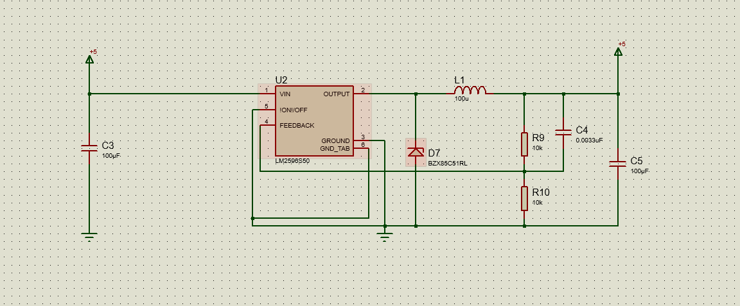

MẠCH CHÍNH

MẠCH NGUỒN